SARS-CoV-2 Variants Analysis

Objectives

After discussing with Professor Jo Youngji, we realized that combining the two topics into a single discussion is challenging. The first topic—using the initial growth rate of COVID-19 variants to predict their dominance—is already complex, particularly in terms of the modeling aspects. Therefore, we have decided to address them as two separate research topics. The main points are as follows:

First Analysis
Main topic: How much early share growth rate can predict the future share dominance (general model).
Deliverable goals:
- To evaluate the prediction performance (maximum and duration) of the model.
- To determine the range of growth rates most contributing to the dominance. (by the coefficient)
Utility of the model: our model can predict the future dominance by monitoring the share growth rate of the new variant, based on the specific growth rate before reaching the threshold (20%).

Methods

Sample Collection and Definitions. The GISAID (Global Initiative on Sharing All Influenza Data) COVID-19 collection serves as a vital global repository for SARS-CoV-2 genomic data, enabling researchers worldwide to track the virus's evolution, transmission, and mutations. Since its launch in January 2020, GISAID has been regularly updated with submissions from various countries, showcasing collaborative efforts in combating the pandemic. Notably, nations such as South Korea, the United Kingdom, and the United States have contributed extensively to the database, reflecting their robust genomic surveillance programs. Data is collected through a network of participating laboratories, public health institutions, and universities, where clinical samples are sequenced and analyzed before being uploaded to the platform. Institutions such as the Korea Disease Control and Prevention Agency (KDCA), the UK Health Security Agency (UKHSA), and the Centers for Disease Control and Prevention (CDC) in the U.S. play pivotal roles in their respective countries' contributions. GISAID remains a cornerstone of international cooperation, fostering transparency and accelerating research aimed at understanding and mitigating the global impact of COVID-19.

The GISAID dataset used in this study includes daily infection counts for over 3,000 SARS-CoV-2 lineages from January 2020 to May 2024. We focus on the top 15 countries with the highest cumulative case counts, as they offer the most comprehensive and reliable genomic data. This targeted scope enhances the relevance of the analysis by capturing regions with significant variant activity and diverse epidemic patterns, enabling more meaningful insights into the interplay between viral evolution, transmission dynamics, and geographic context.

Inclusion/Exclusion criteria.

Our model is motivated by the need to understand whether early characteristics of emerging SARS-CoV-2 variants can predict their eventual dominance—defined in terms of both peak prevalence and epidemic duration—at the national level. Specifically, we seek to determine whether information from the initial growth phase of a variant’s spread, captured through national-level share trajectories, can forecast how dominant the variant will become in each country. In this framework, peak refers to the highest domestic share a variant achieves, while duration corresponds to the length of its epidemic wave. This decomposition is grounded in prior work such as Du Plessis et al. (2021), who defined lineage establishment based on a minimum of 10 sequenced cases over 14 days, indicating sustained local transmission. We extend this idea to model and quantify variant-level dominance across countries.

To ensure the reliability of these national-level share estimates, we first identified valid analytical periods for each country, using sequencing coverage standards recommended by the World Health Organization (WHO, 2021). A valid period was defined as a continuous stretch of at least three calendar weeks, each containing at least 100 sequences and four days with non-zero sampling. This ensures that early growth patterns and peak prevalence estimates are derived from consistent, representative data. Following Chen et al. (2022), who showed that sparse sampling introduces significant noise and bias, we retained only those variant–country combinations whose entire observed share trajectories fell within valid periods. This filtering step led to the exclusion of several variants in countries such as the United Kingdom, Sweden, the United States, Japan, Denmark, and South Korea, where early or late-stage sampling did not meet the minimum sequencing criteria. These limitations in temporal sequencing coverage have been similarly noted in WHO surveillance guidance (WHO, 2023), variant tracking literature (Hodcroft, 2021), and lineage dynamic studies (Du Plessis et al., 2021).

To facilitate robust prediction of variant dominance and reduce data sparsity, we grouped over 3,000 SARS-CoV-2 lineages into broader variant categories according to their parent lineages and phylogenetic relationships. This classification consolidates highly granular lineage data into a tractable number of epidemiologically meaningful groups. After removing lineage–country combinations not fully contained within each country’s analytically valid period, the grouping procedure was applied independently for each country to reflect substantial geographic heterogeneity in variant circulation (Hodcroft, 2021; Du Plessis et al., 2021). To ensure analytic relevance, each retained group was required to cause at least 500 infections by August 2024 and to reach a peak domestic share of at least 1%.

For example, in the United Kingdom, 31 variant groups were retained following classification and filtering, including dominant Delta and Omicron sublineages such as AY.4 and BA.1/BA.2. South Korea retained 44 groups, prominently featuring BA.2.3-derived lineages and recombinants like EG.5.1 and FL.10.1. In the United States, 45 variant groups remained, reflecting a broad spectrum of Delta, Omicron, and emergent BQ/HV sublineages. These country-specific groupings align with nomenclature frameworks proposed by Rambaut et al. (2020) and O’Toole et al. (2021), which support hierarchical lineage classification for genomic surveillance and comparative epidemiology.

To further illustrate the classification outcome and our epidemic period definition, Figure 1 displays three common variants observed in the UK, US, and South Korea. For each, the shaded region indicates the epidemic period as defined earlier starting from the initial rise and ending when the variant falls below sustained prevalence. The peak is defined as the variant’s highest observed domestic share, while the duration corresponds to the length of the shaded epidemic window. This visual representation highlights how our definitions capture both the timing and magnitude of variant dominance across regions.

Figure 1: Illustration of three common variant groups observed in the United Kingdom, United States, and South Korea. The shaded areas represent each variant’s epidemic period, defined from initial rise to sustained decline based on domestic share. The peak corresponds to the highest observed share within this period, while the duration reflects the length of the shaded window, capturing the temporal extent of dominance.

To evaluate whether early-stage characteristics can predict a variant’s eventual dominance, we define the initial period as the time prior to when a variant reaches 20% domestic share within a country. This threshold is chosen to capture the early expansion phase before a variant gains dominance, minimizing reverse causality. The 20% cutoff has been used in previous studies to identify phases of meaningful growth, including Obermeyer et al. (2022) and McBroome et al. (2023), who applied similar criteria to estimate fitness advantages and predict competitive success. Unlike definitions based solely on fixed durations or total case counts (e.g., Du Plessis et al., 2021; Yang et al., 2022), this prevalence-based approach offers greater flexibility across countries and variants with heterogeneous epidemic trajectories.

To further ensure comparability and prevent dominance signals from contaminating early-stage indicators, we additionally incorporate a time-based safeguard: if a variant does not exceed the 20% threshold within a pre-defined time window—set at 14, 21, or 28 days based on WHO sequencing guidance (WHO, 2021) and genomic surveillance practice (GISAID, 2024)—we use that fixed window as the initial period. Variants that exceed the 20% share within this window are excluded from early-stage modeling, as they have already demonstrated dominance potential. This combined prevalence-and-duration framework balances epidemiological relevance, statistical consistency, and global surveillance feasibility, aligning with practices recommended in recent variant assessment efforts (Britton et al., 2023; Chen et al., 2022).

Statistical Methodologies (Dominance Prediction).

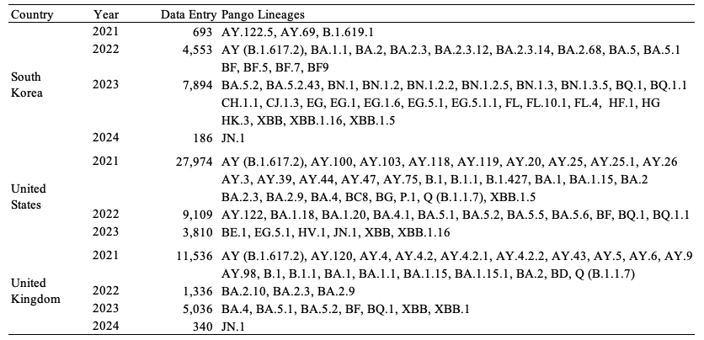
Table 1. descriptive summary of data input by 3 countries.

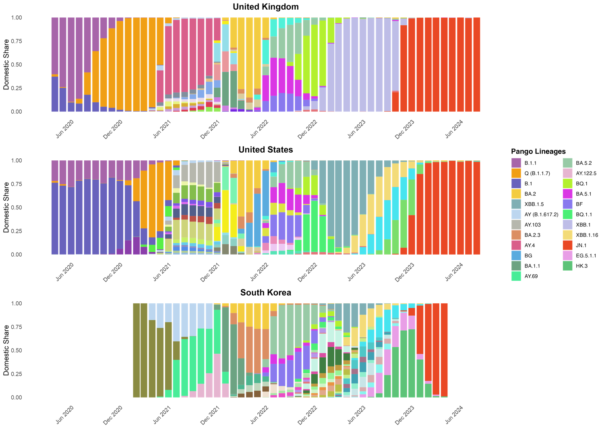
Figure 1. descriptive summary of variants time series distribution by United Kingdom, United States and South Korea. (why South Korea truncated in this way)

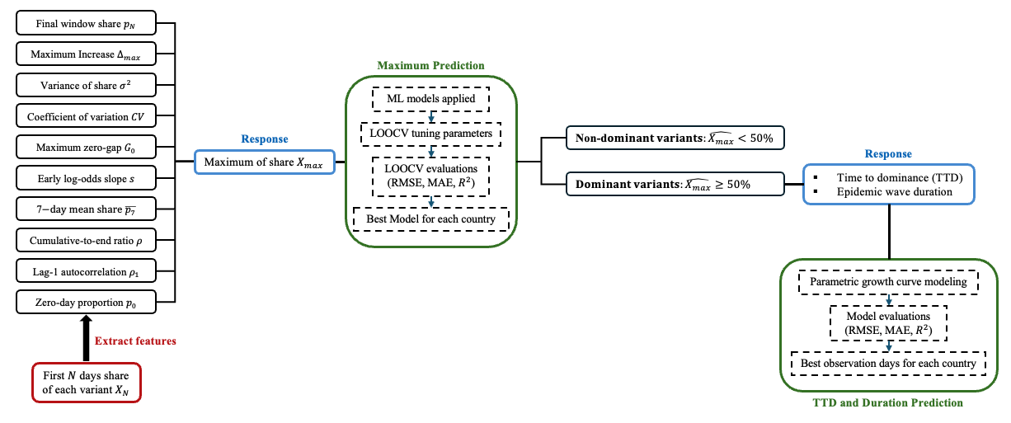
Figure 2. data/model flow

Results
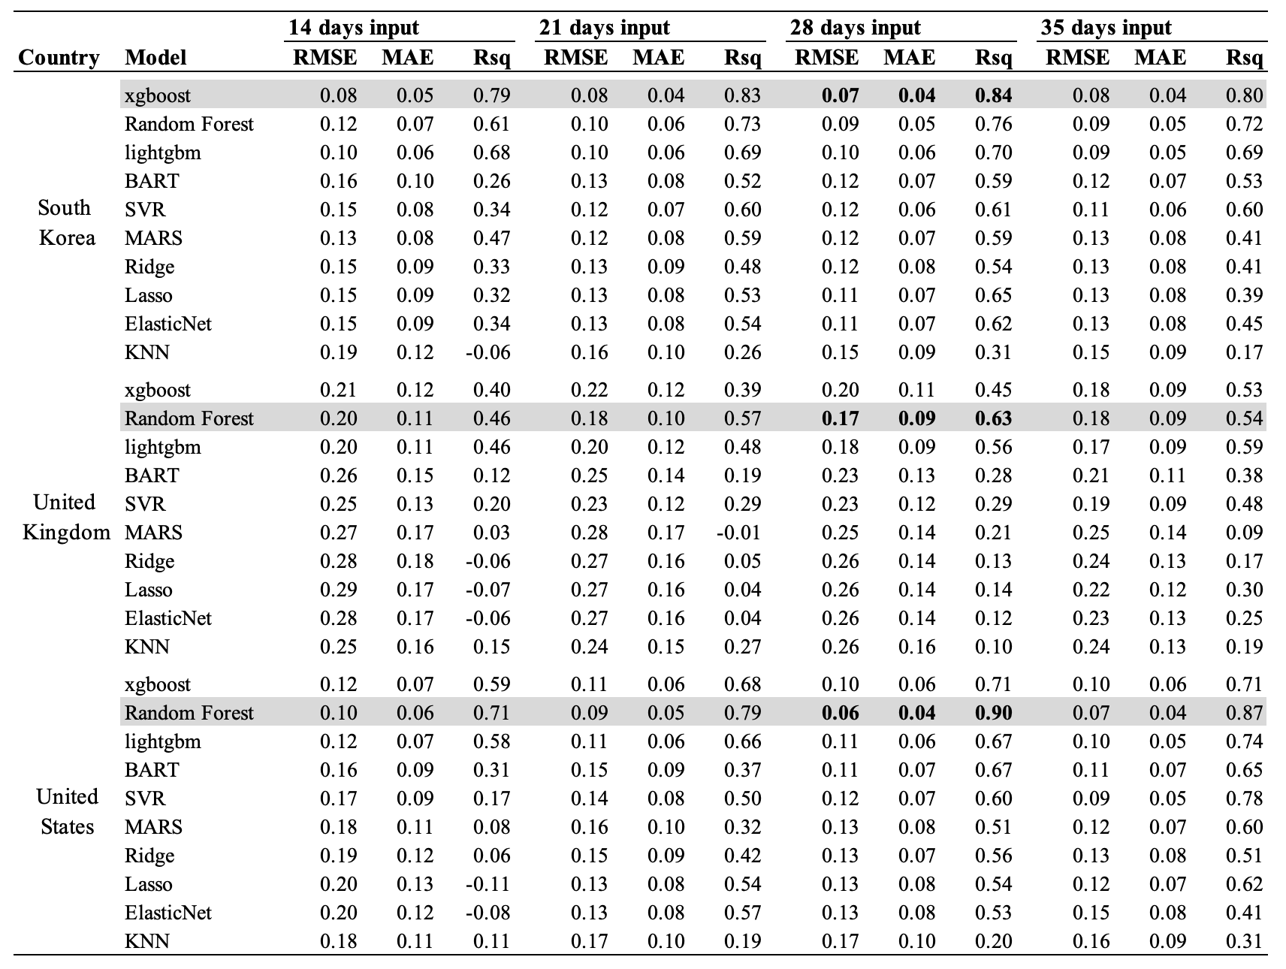
Table 2. model performance of maximum prediction (evaluated via LOOCV)

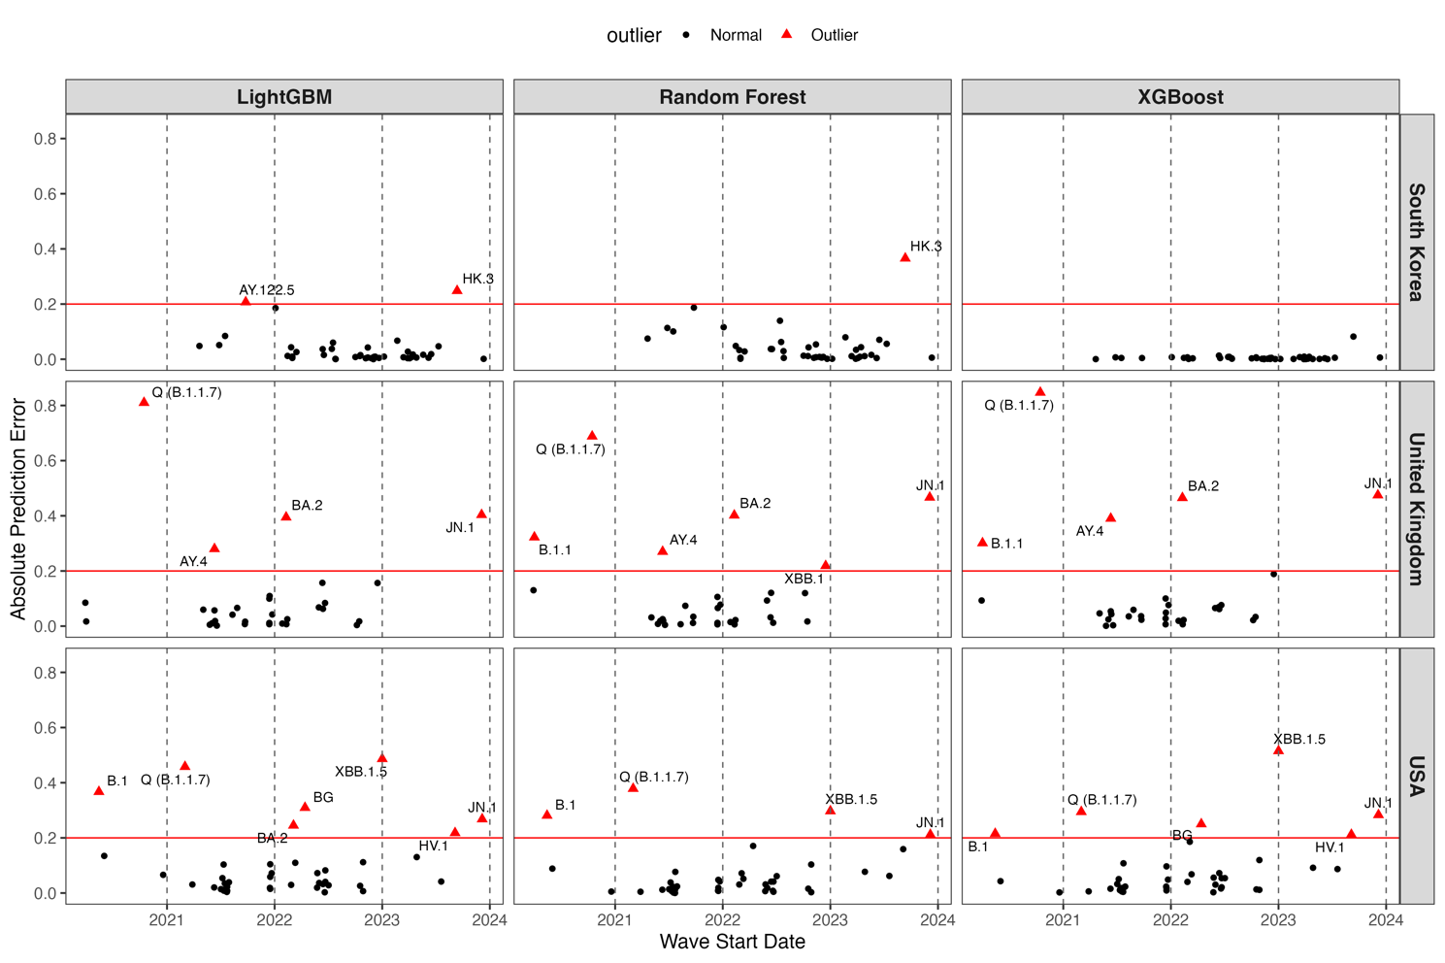
Figure 3. maximum prediction box plot over time by model
(model performance by specific variants/time/countries)-once we know the best performance model, apply that model for different variants in different time and show the performance

Table 3. model performance of time to max and duration
Figure 4. growth curves by countries by model (panel A and B)

In our analysis, we tuned the maximum observation window and the minimum required days for model inclusion. The tuning ranges were set to 3, 4, and 5 weeks for the maximum observation window, and 7 and 14 days for the minimum requirement. Separate prediction models were fitted for peak magnitude and duration. The results are presented in Table 2 and Table 3. Across all settings, model performance consistently improved with a larger observation window, indicating that variants with low initial prevalence benefit from longer input periods to achieve accurate predictions. In contrast, increasing the minimum required days reduced the number of variants included in the model, and the improvement in performance was relatively marginal. Based on these results, the configuration with a 5-week maximum observation window and a 1-week minimum requirement is preferred for balancing performance and coverage.
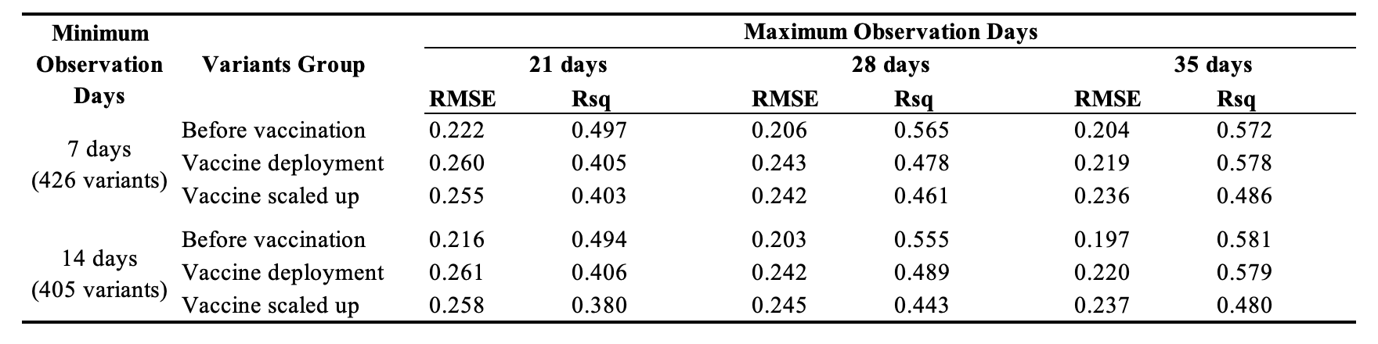
Table2: Model tuning results for maximum prediction.

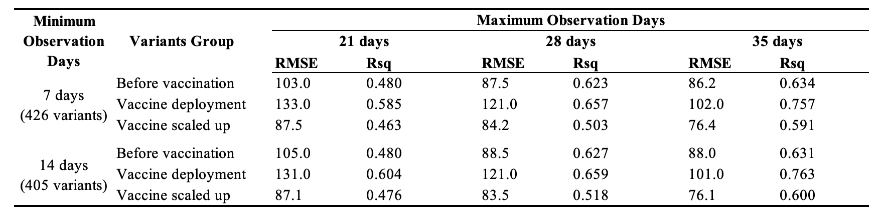
Table3: Model tuning results for duration prediction.

With the preferred configuration, the functional regression models were fitted based on the minimum mean 5-fold cross-validated RMSE. In total, three models were constructed for predicting the maximum domestic share and three for predicting the duration of variant circulation. The estimated functional coefficients for growth rate are shown in Figure 2 and Figure 3.

For the maximum prediction models, the Before Vaccination and Vaccination Scaled Up groups exhibit similar patterns: growth rates between 0% and 20% are positively associated with the maximum domestic share of the variant. However, in the Vaccination Scaled Up group, growth rates exceeding 25% show a negative contribution. In contrast, the Vaccine Deployment group displays less consistent or interpretable patterns.

Regarding the duration prediction models, across all groups, growth rates above 25% are strongly negatively associated with variant duration, while moderate growth rates (0% to 20%) tend to have a slight positive effect.
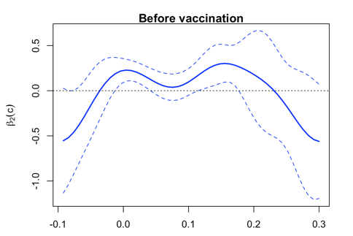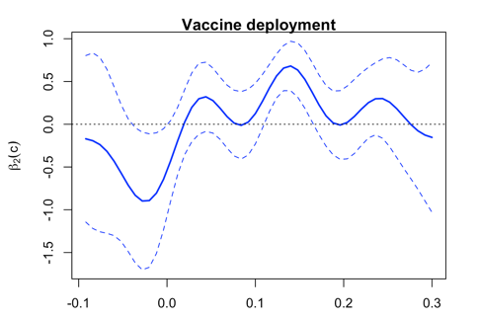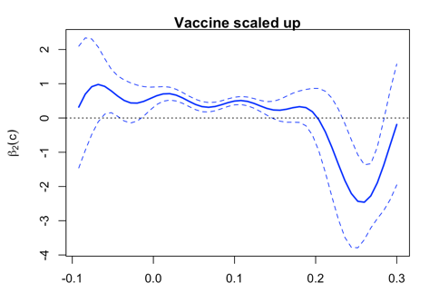
Figure 2: Fitted growth rate coefficients $β_{2}(c)$ for maximum models

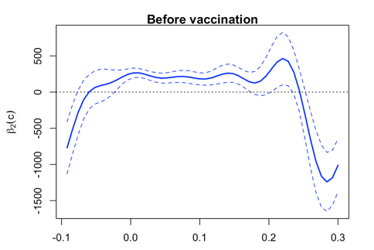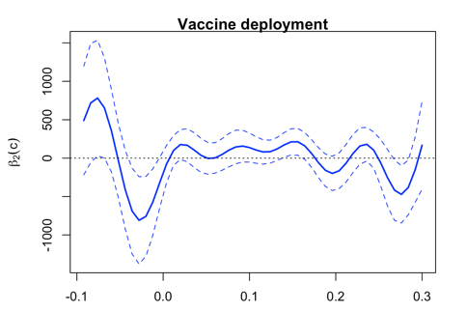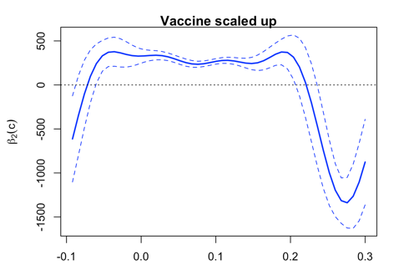
Figure 3: Fitted growth rate coefficients $β_{2}(c)$ for duration models

Appendix

